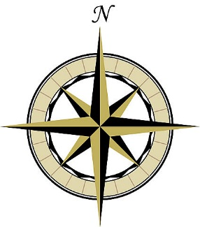
Your True North Questions
Use these questions as a springboard for personal reflection, small group discussion, or
to do your own interview with a friend or family member

- What are 3 core values or guiding principles that really define who you are as a human being?

- Which life experiences helped you identify each of these values?

- What is your values ‘origin story,’ or what have been the key influences that have shaped your values, especially in childhood?

- Has religion or spirituality influenced your values? If so, in what ways?

- What’s the personal relationship that has most affected your values?

- How do you see your values influencing your life day-to-day?

- What do you see as the intersection between your values and your work?
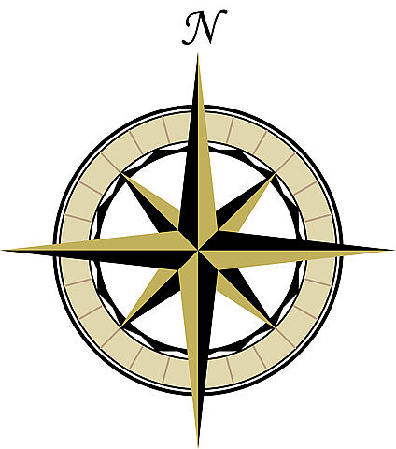

- In situations where you’ve strayed from your values, what did you learn?

- What specific values would you like to pass on to the younger people in your life?

- Has living according to your values gotten easier or harder as you’ve gotten older?

- Do you have a favorite poem, song, or saying that helps you live a value-centered life?

